Create Food Items

Document Information

|  |  |
| --- | --- |
| **Document Title** | Title of use case – Verb Noun phrasing is almost always the most appropriate! |
| **Document Owner** |  |
| **Version** |  |
| **Status** |  |
| **Date** |  |

1. Brief Description

This use case allows the school administrator to add new food items to the system, including details such as food name, price, dietary restrictions, allergies, and quantity limits.

1. Actors

* School Administrator

1. Trigger

The school administrator needs to add a new food item to the system.

1. Pre-Conditions

* The school administrator has logged in to the system.

1. Post-Conditions

* The new food item is added to the system and available for ordering.

1. Basic Flow
2. The school administrator selects the “Food Item” menu.
3. The system displays Food Item page that displays food items available on the SLOS.
4. The school administrator selects Create button to create a new food item.
5. The system displays a form to input the food item details.
6. The school administrator inputs the food name, price, description, dietary restrictions, allergies, and quantity limits.
7. The school administrator selects Save button to submit the form.
8. The system validates the input and adds the new food item to the system.
9. The system redirects to the Food Item page.
10. Alternate Flows
11. Exception Flows

* 7a: If there is a validation error, such as a missing field, the system displays an error message and prompts the school administrator to correct the input.
* 7b: If there is the same food name existed, the system displays an error message and prompts the school administrator to input another name.
* 7c: If the system is unable to add the new food item due to system availability issues, the system displays an error message and prompts the school administrator to try again later.

1. Business Rules

* The food item name must be unique.
* The food item price must be a positive value.
* The quantity limit must be a positive value.
* Only the school administrator has the permission to update food items.

1. Non-Functional Requirements

* The system should be able to handle a large number of food items efficiently (~ 10,000).
* The system should be able to validate the input and add new food items quickly (1s-2s).

1. Supplemental Requirements
2. Visual Model

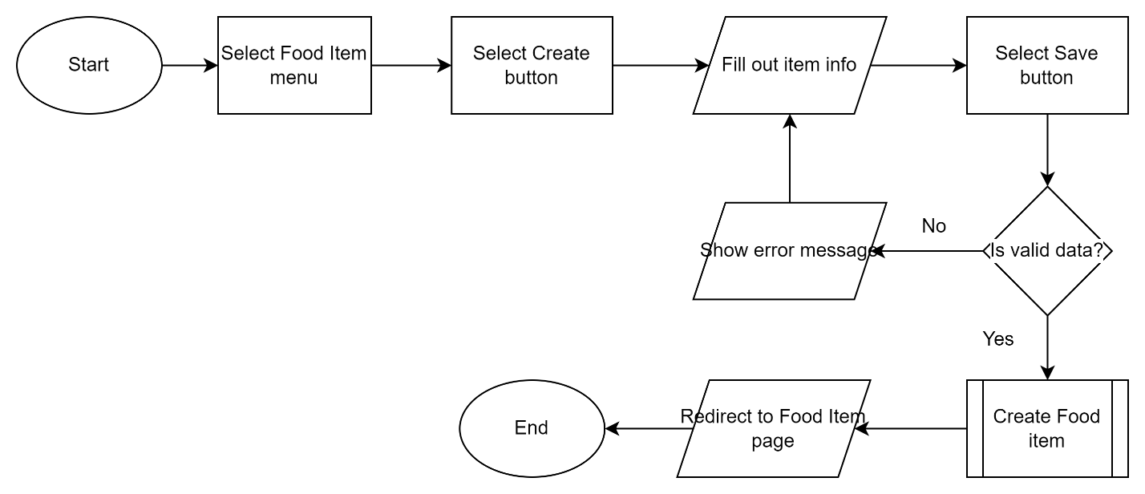

Revision History

|  |  |  |  |  |
| --- | --- | --- | --- | --- |
| V. | Date | Author | Description | Status |
|  |  |  |  |  |
|  |  |  |  |  |